MAN Packing List Template_EN
Version: 1.3

Vs. | Date | Chapter | Kurze Beschreibung der Änderung | Autor
1.0 | 17.01.2020 | all | Document released | M. Tomaschewski
1.1 | 31.07.2020 | All | Document revised | D. Lubitsch
1.2 | 18.08.2022 | All | Document revised | D. Glas
1.3 | 03.11.2023 | All | Document revised | D. Glas

Content
1. Introduction 1
2. Description of the pop-up: 2
3. Description of the worksheets 3
4. Filling out the worksheet “Packing List (PL)“ 5
5. The Use of the import function 10
6. Plausibility check 10
7. Generation of the Supplier’s Declaration 11

Introduction
The packing list was developed at MAN to fulfill all legal ex- and import requirements. For this reason, it is important to provide all required information on time, so that there are no delays in the delivery process.
In this documentation, we describe all functions of the packing list in its current version. If you have any questions, please contact the responsible expeditor.

Description of the pop-up:
As soon as the packing list is opened, the following pop-up appears:
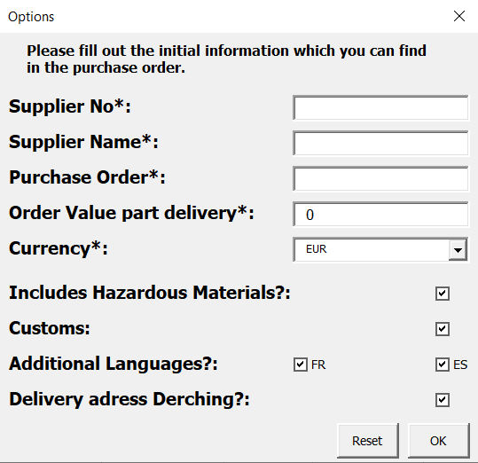
Please fill in the required fields with the information you have from the purchase order.
- Supplier Number
- Supplier Name
- Purchase Order
- Order Value part delivery
- Currency
After the input of your data, the lines in the packing list will be filled in automatically.
The checkboxes blend in the appropriate columns if necessary.
- Hazardous Materials: Tick if you deliver hazardous materials
- Customs: Tick if we have origin requirements for the material and sub
Positions, spare parts or accessories are available
- Language: Tick if the French or Spanish material description is required
- Delivery to Derching: Tick if delivery address is Derching
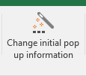
It is possible to edit the data again by clicking on the button "Change initial pop up information" shown in the picture, which you will find in the menu bar.

Description of the worksheets
Packing List (PL)
The purpose of the packing list is to describe the individual data of the components. You must enter this data.
A more detailed explanation of the respective columns is given in the next chapter. You can also see an explanation in the comment field by moving the mouse cursor over the respective column header in line 11 of the packing list.
Instructions (EN)
The worksheet “Instructions” contains a description of the menu bar and the worksheets, as shown in the following picture. A click on an icon will lead you to the respective description.
As an example, you can see how to access the print settings by clicking the "Prints" icon:
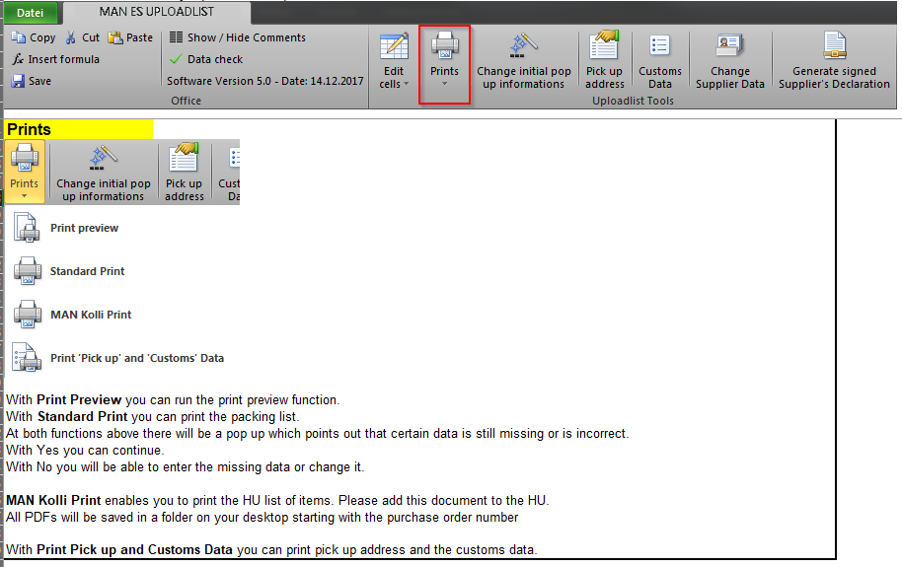
Instruktionen (DE)
This worksheet provides the instructions in German.

Supplier’s Declaration
This worksheet, together with the worksheet Packing List (PL), is used as a supplier’s declaration for the goods of the respective purchase order. It only has to be filled in if sub items (column K), spare parts (column L) or accessories (column M) are available.
The preparation of the supplier’s declaration is explained in chapter 7.
Transport and storage Instructions
This worksheet gives us instructions if HUs are tiltable, stackable and/or can be stored outside or not.
All HUs from the Packing List (PL) sheet in column AT will be transported automatically to this worksheet. Please fill out the columns C, D and E with the existing drop down menu. The plausibility check (which is explained in chapter 7) will show you missing entries.
Container Details
Should you have goods that are packed in containers, you need to fill out this worksheet completely. You can find further information directly in this worksheet.
ISO-Alphacodes
This worksheet contains a list of countries and their respective ISO-Codes.

Filling out the worksheet “Packing List (PL)“
All columns that are marked with a star (*) at the column header in line 11 have to be filled in. The remaining columns are optional or need to be filled in under specific circumstances. (For example, the column Hazardous Materials Classification (AC) only has to be filled if any hazardous material is part of the delivery content).
The material items must not be listed as a complete component, as in the purchase order, but at individual part level.
Each component that can be individually removed from the package and is not firmly connected to other parts has to be listed.
Should the same components be packed into different packages for packaging reasons, these must be listed in individual lines. However, if several identical components (e.g. 4 pumps) are ordered in one order item and these are packed in one package, they do NOT have to be listed in several lines. In this case the quantity 4 (column Q) can be specified in one line. This applies to both main and sub-items, spare parts and accessories.
With the release of version 5.2, you can find a new function in the menu bar.
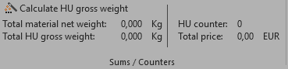
This function will counts the following data:
- Total material net weight
- Total HU gross weight
- The number of HUs
- Total price
This function should give you a fast overview over your inserted data.
If you list the same HU in several lines, please fill out the first line with the weight and dimension data as otherwise there will be an error in the display when you click “calculate HU gross weight”.
This error will be corrected with the plausibility check.
Depending on the resolution of the monitor, respectively if the document is not in full screen mode, it can be the case that the menu bar will be grouped. This can look like this:
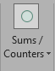 You can see the data by clicking the arrow.
Description of the individual lines of the packing list
To display the comments of the respective columns you can move the cursor over the wanted field at line 11. There you can get an explanation about the content of the column.
Column | Description
G | The MAN Purchase Number.
H | The Purchase Item as per purchase order for the respective main item.
I | The WBS-element as per purchase order. This has to be entered in the format for example 5301960.B.160.010.010.
J | The Main Item depicts the actual Purchase Items as per order and needs to be marked with an X.
K | Sub Items are components that belong to a Main Item but had to be dismantled (for example due to transport reasons). All Sub Items that belong to a Main Item have to be marked with an X.
L | If the Item is a Spare Part, it has to be marked with an X.
M | If the Item is an accessories, it has to be marked with an X.
N | The Material-Number of MAN only applies to Main Items and can be obtained from the respective Purchase Item.
O | The Material Number of the Supplier has to be entered in every line. If you don’t have own material number, please fill in this field with the purchase order number a unique consecutive number (for example: 4500123456-001).  It is not possible to enter more than 35 characters here.
P | If the Catalog Number varies from your Material Number, it can be entered here.
Q | The Quantity has to be entered per position and as a whole number, if the position is a component.  If a component has to be dismantled because of transport reasons, it may not be listed like for example 5 times 0.2 pcs. Instead you have to enter it one time as a Main Item and 4 times as a Sub Item (description, for example, dismantling part of the main position).  Material No. Material No. Supplier Description of Goods Quantity Price Main Item Sub Item HU-Ident  4711 123 Radiator Main Item 1 8000 X HU1  123.1 Radiator Sub Item 1 1 1000 X HU2  123.2 Radiator Sub Item 2 1 500 X HU3  123.3 Radiator Sub Item 3 1 300 X HU4  123.4 Radiator Sub Item 4 1 200 X HU5  If for example fluids are declared in liters, the value can be listed with up to 3 decimal places.
R | The Unit of Quantity of the respective position (for example PC, CM, etc.).
S | The Price per 1 Unit of Quantity is required for main and sub items, as well as spare parts and accessories, for customs declaration and must be indicated per 1 unit of quantity.
T | Total price will be calculated automatically and shows the price per 1 Unit of quantity.  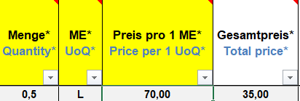  If you want a price of 70€ for 0.5L you have to write down a price of 140€ for 1 unit of quantity.
U | The Currency must be given according to the purchase order. Is transferred from the Pop-Up window.
X | The description of Goods in German language.
Y | The description of Goods in English language.
Z | The description of Goods in French language.
AA | The description of Goods in Spanish language.
AC | If a component is a Hazardous Material, the appropriate Hazardous Materials Classification (1-9) has to be selected.
AD | The Material Netweight in relation to 1 x Unit of Quantity (from column R) with maximum 3 decimal places.
AE | Total weight will be calculated automatically
AF | The Material Dimension in relation to 1 x Unit of Quantity (from column R).
AG | The basic material of the item.
AH | Here, the customs tariff number of the component has to be entered. You can find an overview of the valid custom tariff numbers under https://www.tariffnumber.com/.
AI | The Country of Origin must be entered according to the ISO-Alpha-Codes (see worksheet “ISO-Alphacodes”, for example DE, US, FR, etc.).  For all listed parts, the Country of Origin, according to the non-preferential origin as stated in article 60 & 61 of the Customs Codex, is to be checked and entered in the column “Country of Origin”.  Only necessary if sub items, spare parts and /or accessories are available.
AJ | Enter the Export Classification Code for the parts that have restrictions according to the export list, as stated in the German Foreign Trade and Payments Ordinance (Außenwirtschaftsverordnung, AWV), respectively the Council Regulation (EC) No. 428/2009 (“EU Dual-Use Regulation”) or other regulations for the restriction of foreign trade (for example EU embargo restrictions).  Only necessary if sub items, spare parts and/or accessories are available.
AK | Enter the ECCN numbers for the parts of U.S. origin or that are otherwise subject to the U.S. (Re-) export control law.  Only necessary if sub items, spare parts and/or accessories are available.
AV | For the numbering of the handling unit, use the assigned MAN Carrier Code (as per purchase order) together with a consecutive numbering for the whole project.  For example XY-01, XY-02, etc.  IMPORTANT: The Package number has to be entered in every line.
AW | Entry of the packing type (for example cardboard box, wooden box, bundle, pallet)  The data of the particular package has to be entered here. Information about the Container (seal number) has to be listed in the column “Container”.  IMPORTANT: The packing type has to be entered in every line.
AX | Entry of the net weight of all positions contained in the package (exclusive tare). The information has to be in kilogram. This has to be entered one time for each handling unit.
AY | Entry of the gross weight of all positions within the handling unit (inclusive tare). The entry must be made in kilograms. The entry must be completed once per handling unit.
AZ | Entry of the length in cm. The entry must be completed once per handling unit.
BA | Entry of the width in cm. The entry must be completed once per handling unit.
BB | Entry of the height in cm. The entry must be completed once per handling unit.
BD | In case of container usage please enter the container seal number here.  Please consider the SOLAS formalities and send us the weight certificate together with the packing list.

The Use of the import function
In the No-Macro version, the lines 1-9 and line 12 are blanked. These must remain unchanged. Otherwise, you can make any adjustment you require, such as changing the sequence of the columns.

You can now create your own analyses from your system and copy them to the No-Macro version. For the packaging types, please use the predefined packaging materials from column BB, these are the basic prerequisites for processing the data.
Please also fill in the sheets Supplier’s Declaration, additional Data and Transport and Sorage Instructions. In the last one please use the give data in column H and column I.
As soon as you have finished filling the list, save it and open the macro version of the packing list. Under File - Add-Ins you will find the function Import noMakro. Then select the list you saved previously and load it into the macro version
Now you have the possibility to perform a plausibility check, see chapter 6, and to create the supplier’s declaration, see chapter 7.

Plausibility check
The packing list has a plausibility check, which can be executed by pressing . The Check will then test the entries for reasonableness, for example, whether the gross weight of the package is greater than the net weight. If the check detects an error or a missing field, a corresponding error message appears and the cursor automatically jumps to the field that is not OK. You now have the possibility to correct the field.
The plausibility check must be restarted after each error.
As long as the list is not completely filled correctly, you will see a red X at the data check field. As soon as the list is filled correctly and completely, the symbol becomes a green tick.

If you want to save and/or close a list that is not completely filled, you will also be notified of missing or incorrect fields. You can then decide whether you want to correct or fill them or continue the saving process.

Generation of the Supplier’s Declaration
IMPORTANT:
Transmit the fully completed Supplier’s Declaration together with the fully completed Packing list as PDF file to MAN Energy Solutions.
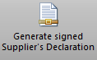
Procedure:
- After the entry of your Data in the register “Packing List (PL)” and “Supplier’s Declaration” you have to click on the button “Generate signed Supplier’s Declaration” in the menu bar.

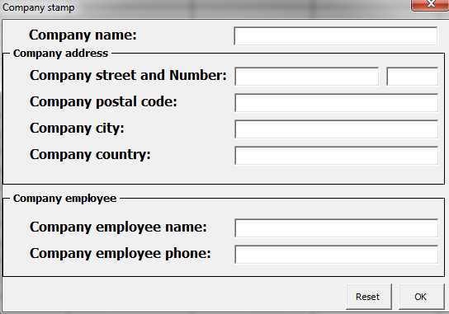
- The following form opens:

- Fill in the fields completely and confirm by clicking on “OK”.

- Now a PDF file (consisting of the Supplier’s Declaration and the packing list) is generated. It contains a digital stamp with the data you have stored in the fields of the input mask.

- Finally a prompt to save appears.

